**Ex.no:7**

**Date:19/4/25**

**7.Write a servlet to program to store a user’s preferences(like theme or language) using cookies.Retrive and display these preferences on subsequent visits.**

**Aim:**

To Write a Servlet to demonstrate the difference between HTTP GET and POST

By creating a form and handling requests accordingly .

**Program:**

**Cookie.html**

<!DOCTYPE html>

<html>

<head>

<meta charset=*"ISO-8859-1"*>

<title>Insert title here</title>

</head>

<body>

<form method=*"post"* action=*"http://localhost:7750/Dynamic_web_project_muthulakshmi/Cookie1"*>

<p>

<label>Theme: </label>

<input type=*"text"* name=*"theme"* required>

</p>

<p>

<label>Language: </label><br>

<input type=*"radio"* name=*"language"* value=*"English"* required> English<br>

<input type=*"radio"* name=*"language"* value=*"Tamil"*> Tamil<br>

<input type=*"radio"* name=*"language"* value=*"Hindi"*> Hindi<br>

</p>

<button type=*"submit"*>Submit</button>

</form>

</body>

</html>

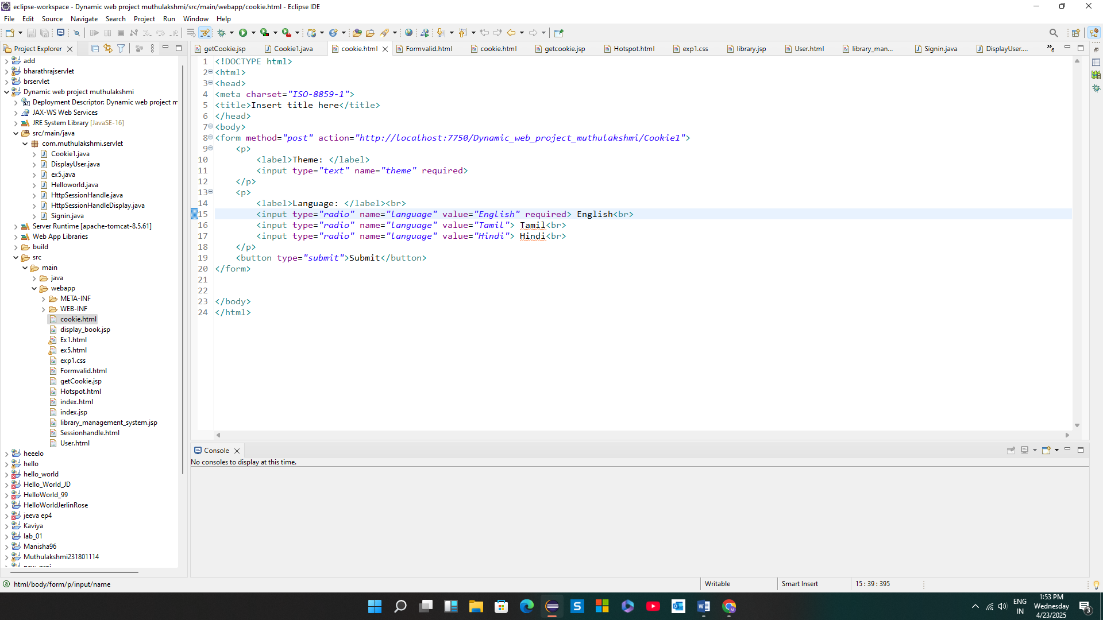

**getCookie.jsp**

<%@ page language=*"java"* contentType=*"text/html; charset=ISO-8859-1"* pageEncoding=*"ISO-8859-1"*%>

<!DOCTYPE html>

<html>

<head>

<meta charset=*"ISO-8859-1"*>

<title>Get Cookie</title>

</head>

<body>

<%

Cookie[] cookies = request.getCookies();

String theme = **null**;

String language = **null**;

**if** (cookies != **null**) {

**for** (Cookie cookie : cookies) {

**if** ("theme".equals(cookie.getName())) {

theme = cookie.getValue();

} **else** **if** ("language".equals(cookie.getName())) {

language = cookie.getValue();

}

}

}

**if** (theme != **null** && language != **null**) {

out.println("Hi! Your theme is <b>" + theme + "</b> and preferred language is <b>" + language + "</b>.");

} **else** {

out.println("No cookies found.");

}

%>

</body>

</html>

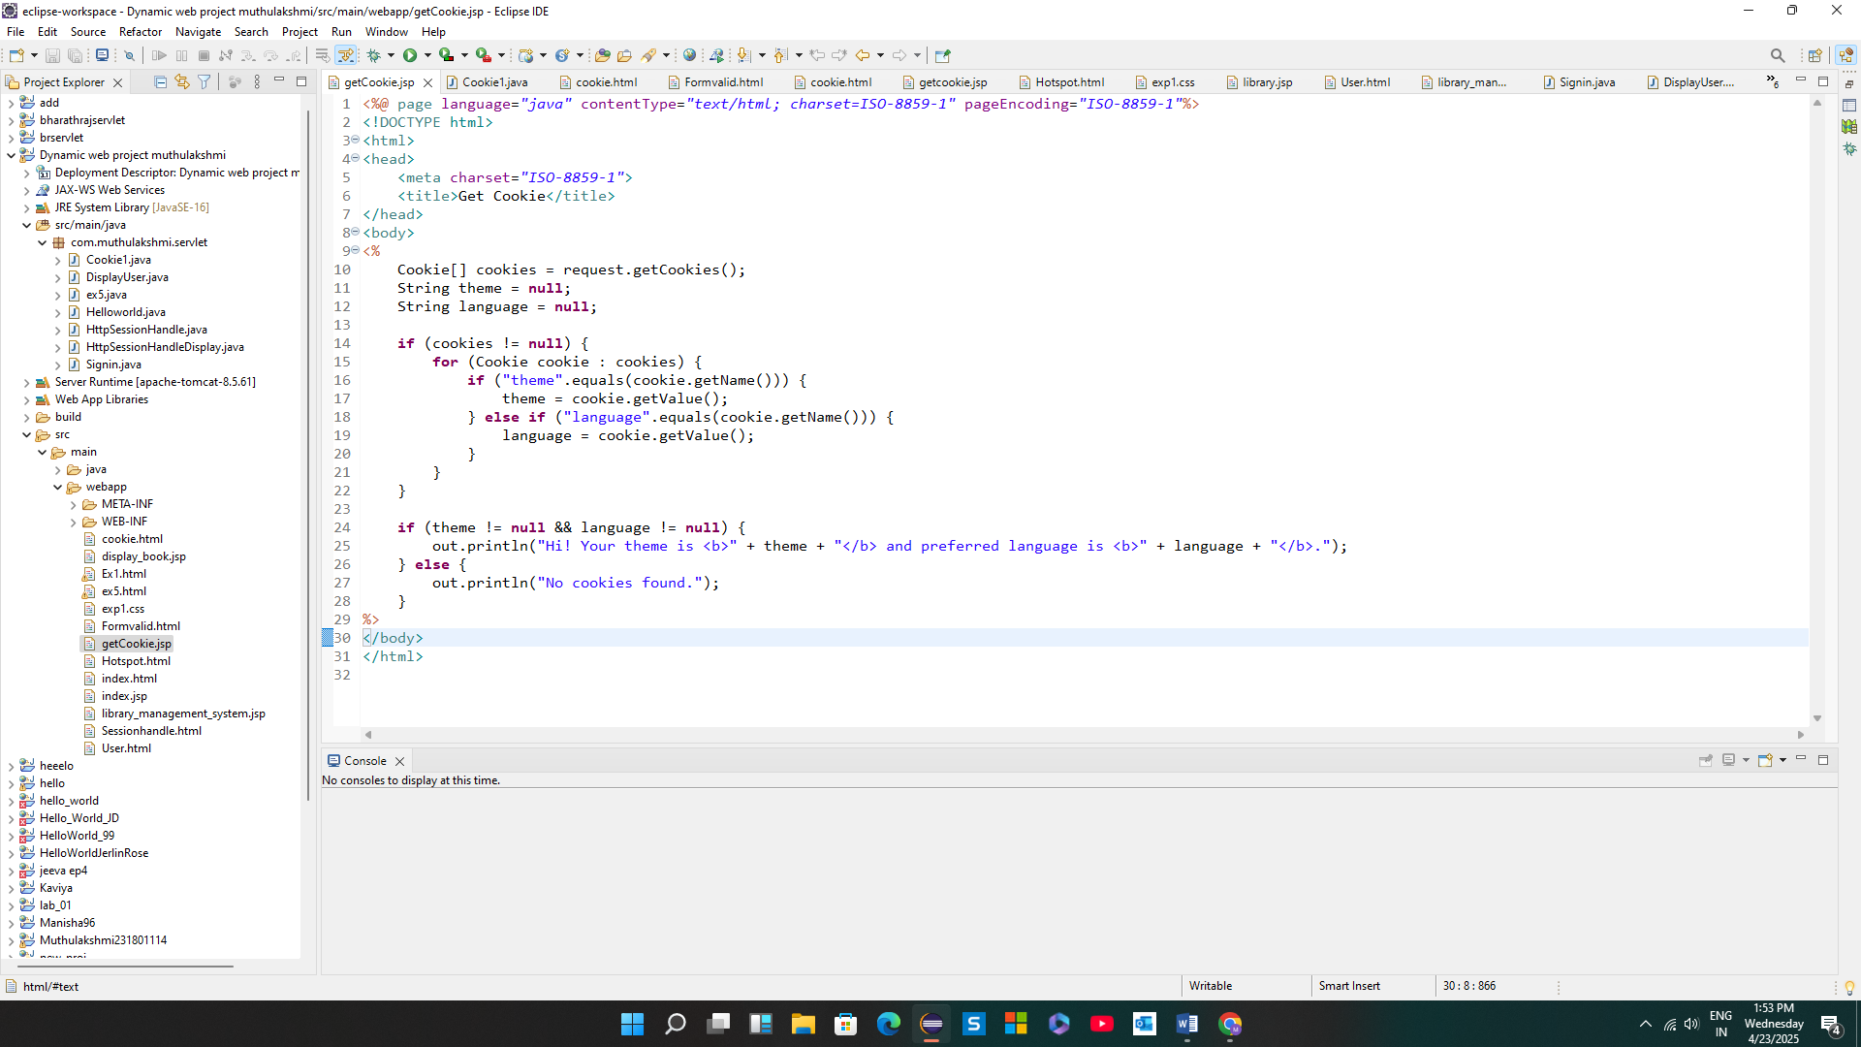

**Cookie.java**

package com.muthulakshmi.servlet;

import java.io.IOException;

import javax.servlet.ServletException;

import javax.servlet.annotation.WebServlet;

import javax.servlet.http.Cookie;

import javax.servlet.http.HttpServlet;

import javax.servlet.http.HttpServletRequest;

import javax.servlet.http.HttpServletResponse;

@WebServlet("/Cookie1")

public class Cookie1 extends HttpServlet {

private static final long serialVersionUID = 1L;

public Cookie1() {

super();

}

protected void doPost(HttpServletRequest request, HttpServletResponse response) throws ServletException, IOException {

String theme = request.getParameter("theme");

String lang = request.getParameter("language");

// Check if values match specific criteria

if ("nature".equalsIgnoreCase(theme) && "tamil".equalsIgnoreCase(lang)) {

// Create cookie with proper name and value

Cookie themeCookie = new Cookie("theme", theme);

themeCookie.setMaxAge(60 * 60); // 1 hour

themeCookie.setPath("/");

response.addCookie(themeCookie);

Cookie languageCookie = new Cookie("language", lang);

languageCookie.setMaxAge(60 * 60);

languageCookie.setPath("/");

response.addCookie(languageCookie);

response.sendRedirect("getCookie.jsp");

} else {

response.getWriter().println("Invalid login!");

}

}

}

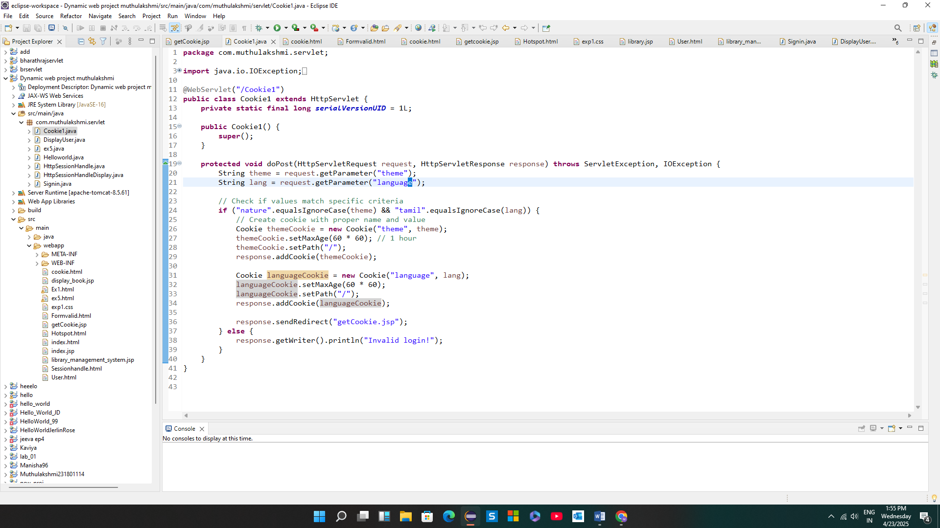

**Output:**

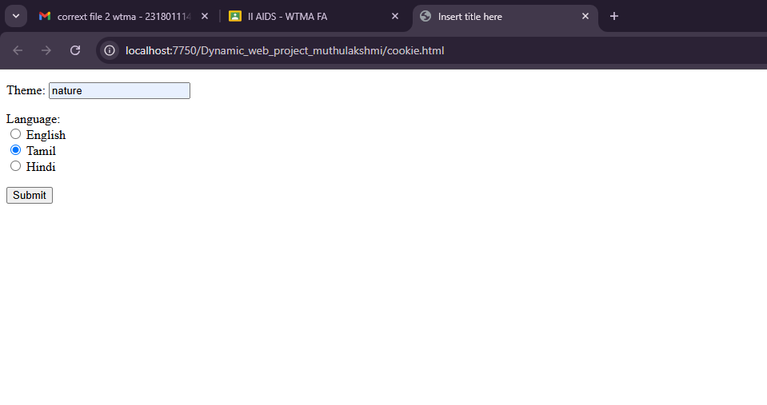

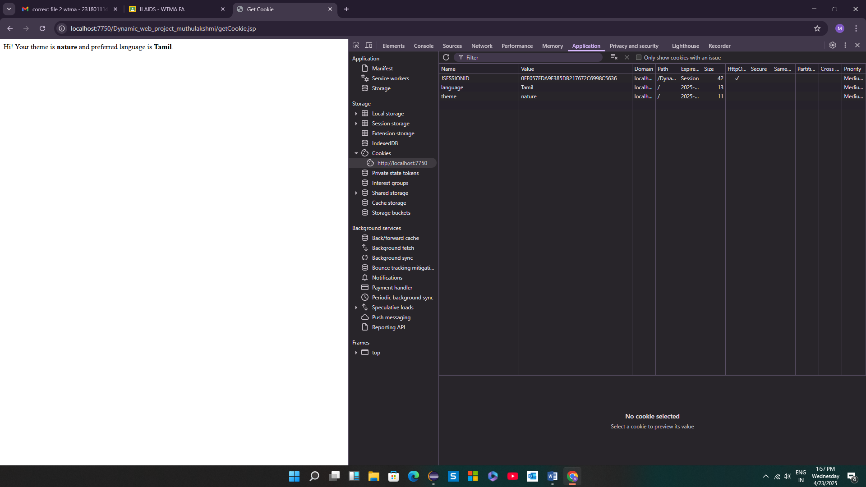

**Result:**

Thus Write a servlet to program to store a user’s preferences(like theme or language) using cookies.Retrive and display these preferences on subsequent visits.